Appendix 3

Template - Community Lone Working Risk Assessment
Officer(s):
Date of assessment:
Review date:

Activity & Hazards | Risk rating  L x S = R |  |  | Current Risk Controls | Additional Risk Controls | New Risk Rating  L x S = R
- Driving:  Vehicle breakdown  Accident Intruder in vehicle when unattended  Use of mobile phone Fatigue |  |  |  | Maintain vehicle properly  Belong to a breakdown organisation  Carry torch, phone etc for emergency  Do not leave valuables in car  Avoid risky areas where possible  Plan your route  Ensure adequate fuel in vehicle  Take precautions in adverse weather. | Advise other staff where you are going  Phone office if plan changes  Use public transport if available
- Movement through public areas e.g. to/from car parks:  Attack  Theft of property |  |  |  | Back down from confrontation  Call for help  Keep valuables secure and out of sight or disguised  Surrender valuables if personal safety is at risk | Use public transport if available  Carry attack alarm
- Illness or injury/accident |  |  |  | Alert team members if able to Ensure access to phone  Take prescribed medication as directed or as needed | Contact ambulance service
- Contact with third parties:  Assault  Verbal abuse  Threats |  |  |  | Pre-planned visit  Use techniques to avoid conflict  Be aware of own responses  Staff briefings and sharing information | Avoid meetings attended by people known to display threatening behaviour
- Manual handling  Back injury Slip, trip or fall |  |  |  | Minimise manual handling  Do not attempt alone if beyond capabilities  Wear appropriate footwear  Assess floor conditions (slippery, wet, rugs etc) | Use lifting aids  Don’t lift if in doubt
- Attack by dog or other animal:  Bites  Contracting illness  Shock |  |  |  | Avoid contact with animals  Seek local advice before entering premises with animals | Appropriate behaviour near animals – avoid alarming them, e.g. sudden movements

Assessor’s Name: | Signature: | Date:

Clerk’s Name: | Signature: | Date:

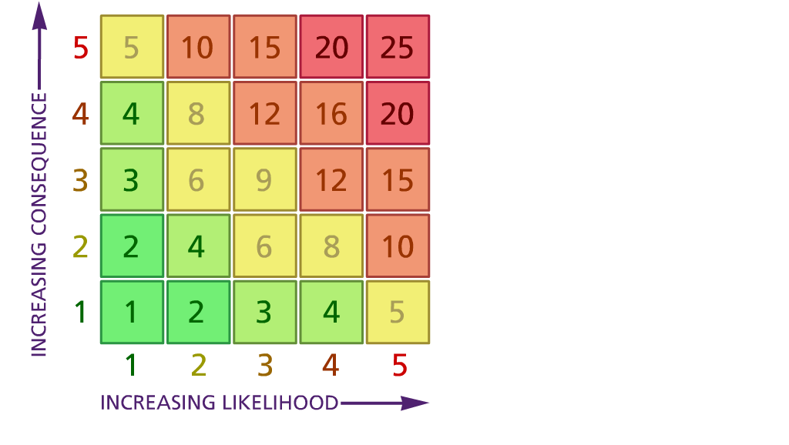
Likelihood |  | Severity
1 | Very unlikely (5 years or more) | 1 | Very minor injury / Very limited property damage/loss
2 | Unlikely (1-5 years) | 2 | More serious injury <3 days off  work/incapacity (sprains, more  serious cuts, bruising. Injury needing  medical attention. Slight property damage/loss
3 | Likely (6-12 months) | 3 | RIDDOR reportable (to HSE)  injury/sickness (except fatality). More than 3 days off school. Significant  property damage/loss
4 | Very likely (1-6 months) | 4 | RIDDOR reportable (to HSE)  injury/sickness affecting more than one person (excluding fatality). Major property damage/loss.
5 | Certain (more than 1 per month | 5 | Single or multiple staff fatality.  Catastrophic property damage/loss.

