Appendix 4

Template - Establishment Lone Working Risk Assessment
Officer(s):
Date of assessment:
Review date:

Activity & Hazards | Risk rating  L x S = R |  |  | Current Risk Controls | Additional Risk Controls | New Risk Rating  L x S = R
- Working in office/premises alone:  Fire |  |  |  | Fire detection system  Fire alarm call points  Extinguishers  Fire exits kept clear  Planned inspections  Hazard reporting and  correction  Adequate cleaning/  waste disposal  Electrical safety inc  PAT testing  No smoking, or  controlled smoking  environment | Cheshire East Council BSO to oversee safe evacuation  Return to office only when BSO has given the all clear
- Working in office/premises alone:  Intruder |  |  |  | On-site security (BSO)  Challenging unknown  visitors where safe or  reporting/requesting  assistance from BSO  Access to phone  Keep valuables locked up or out of sight | Alert BSO of lone working and request no visitors are sent to the office without first placing a phone call
- Illness or injury/accident: |  |  |  | Alert team members if able  Access to phone  Take medication as directed or as needed  Planned inspections of  workplace  Avoid high risk  activities (e.g. working at height)  Report faults and repair process  Provision of first aid  equipment  Trained first aider  Electrical safety | Contact ambulance service
- Contact with public:  Assault  Verbal abuse  Threats |  |  |  | Conflict awareness training  Avoid conflict – use non - threatening body language Withdraw politely from situations which become inflamed Staff briefings and sharing information Awareness of risks | Call BSO for assistance
- Manual handling  Back injury Slip, trip or fall |  |  |  | Minimise manual handling  Do not attempt alone if beyond capabilities  Wear appropriate footwear  Assess floor conditions (slippery, wet, rugs etc) | Use lifting aids  Don’t lift if in doubt

Assessor’s Name: | Signature: | Date:

Clerk’s Name: | Signature: | Date:

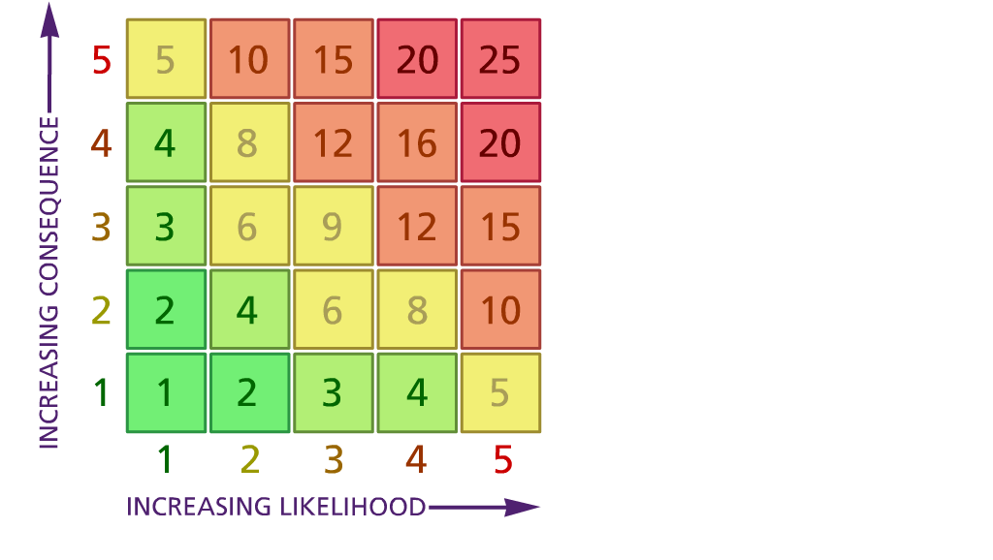
Likelihood |  | Severity
1 | Very unlikely (5 years or more) | 1 | Very minor injury / Very limited property damage/loss
2 | Unlikely (1-5 years) | 2 | More serious injury <3 days off  work/incapacity (sprains, more  serious cuts, bruising. Injury needing  medical attention. Slight property damage/loss
3 | Likely (6-12 months) | 3 | RIDDOR reportable (to HSE)  injury/sickness (except fatality). More than 3 days off school. Significant  property damage/loss
4 | Very likely (1-6 months) | 4 | RIDDOR reportable (to HSE)  injury/sickness affecting more than one person (excluding fatality). Major property damage/loss.
5 | Certain (more than 1 per month | 5 | Single or multiple staff fatality.  Catastrophic property damage/loss.

