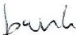
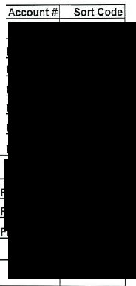
# Pa to
- Cheshire Tree Fellin
- Cheshire East Council
- Cheshire East Council
- Libb s Patch Ltd
- White Blossom Interiors
- Local Peo le Ma azines ltd
Invoice No.
7 PQR Ltd tla Shires
4112
117000327197
11700327228
INV-0030 2025/062
13193
PAYROLL
Amount
£1,590.00
£243.41$
£166.00
£270.00
£175.00
VAT
Total Detail
£0.00 £1.590.00 Allotment tree work
£0.00
£0.00
£0.00
£0.00
£405.00 £81.00
£243.46 Old Police station stora e 17Se t to 300ct
£166.00 Old Police station stora e November
£270.00 Pum kins
£175.00 Lar e floral arch
£486.00 November 2025 full a e advertisement
£23,666.15 £0.00 £23,666.15 November a roll
Date of Invoice
20/10/2025
22/10/2025 VERIF
22/10/2025 VERIF
23/10/2025 VERIF
25/10/2025 VERIF
23/10/2025 VERIF
01/11/2025 VERIF
28-0ct-25
149270
149271
Jul-25
£250.00 £0.00
£250.00 Sto ellin event NatureNeedsYou
9 Four Oaks Nurseries ltd 1O Four Oaks Nurseries Ltd
11 The Monocle Cafe
£34.85 £6.97
£18.00
£3.60
12
£150.00 £0.00
£0.00
£41.82 T herin ton ward bulbs
£21.60 Winter beddin
£150.00 Colourin a es
£0.00
28/10/2025
23/10/2025 VERl
23/10/2025 VERI
01/09/2025 VERl
13
£0.00
£0.00
14 £0.00 £0.00
15 £0.00 £0.00
161
17�
1
11
+
+ ==£0".0+0 - £0'.0"0 "-'"'+
1
+
1
+
+-£=0.0=0
1 £0.00 =-==+
+
+
!
1
1
After viewin the invoices, I have examined, verified and certified the above a ments and bank details and confirm that a men!can be made:
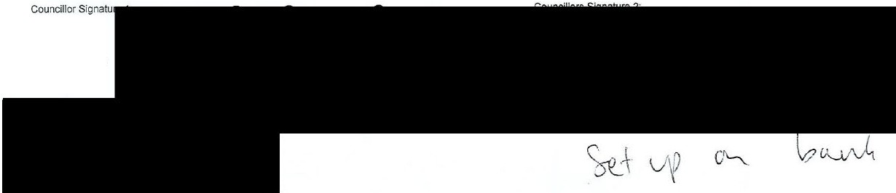
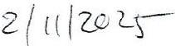
Office Signature:
Y-/(I I2&1s-

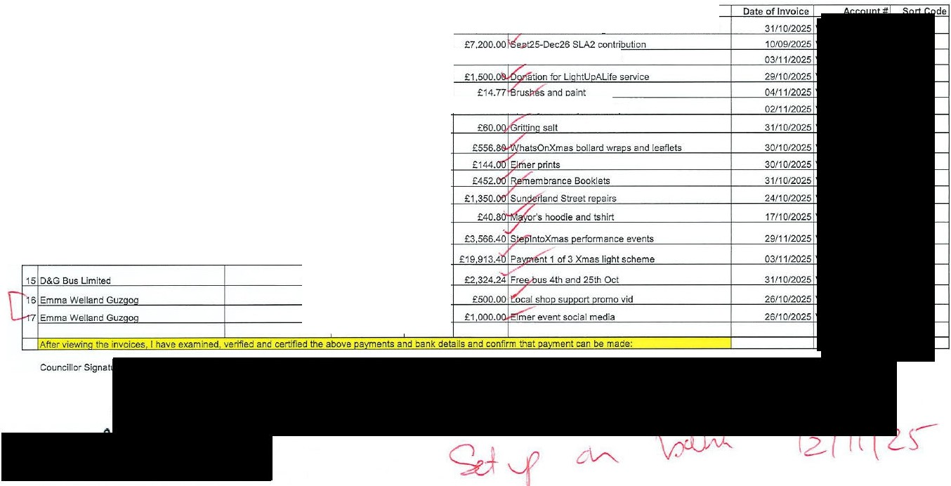
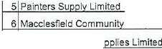
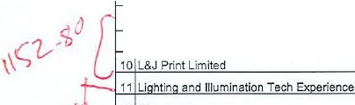
V,, )
Invoice No.
INV-7838 INV-4769
5344
RE61051 85363
211252
6318
Amount VAT
£1,200.00 £240.00
£6,000.00 £1 200.00
Nov25 to Nov26 Incl maint
£560.00
£1,500.00
£12.31
£600.00
£50.00
£112.00
£0.00
£2.46
£0.00
£10.00
internal audit 25/26
Arts ace
worksho s
- Shenton Garden Su
- L&J Print Limited 9
14538
14539
14559
671105
£464.00
£120.00
£452.00
£1,125.00
£92.80
£24.00
£0.00
£225.00
l's Paradise
010 £1,000.00 £0.00
Office Signature:
L&J Print Limited
East Cheshire Hos ice
4
JOH Business Services Ltd
3
CVS Cheshire East
2
Sava e & Gra Desi n Ltd
1
Pa to
#
.IJ, | 1�- ssworx | 510052  INV-19798 | £34.00  £2,972.00 | £6.80  £594.40
l,.\. \ | htin and Illumination Tech Ex erience | 671254 | £16,594.50 | £3.318.90
 |  | 10946 | £2 324.24 | £0.00
 |  | 011 | £500.00 | £0.00



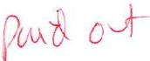
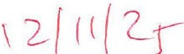

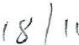
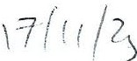
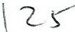
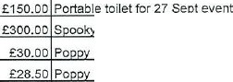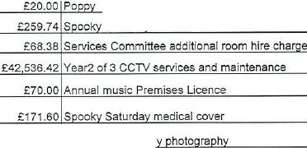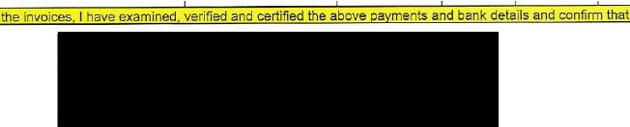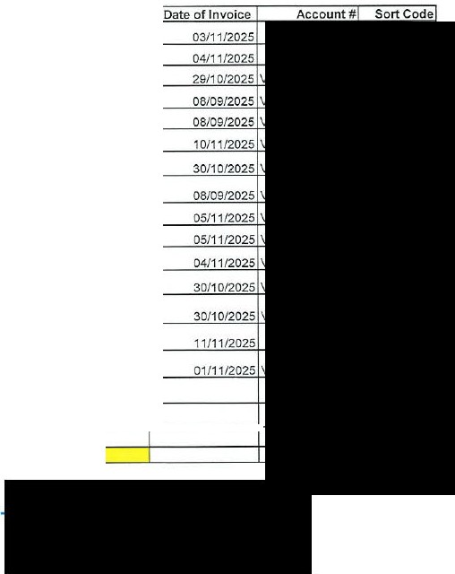
# Pa to
- Macclesfield & Bollin ton URC Chari
- Stu's Loos ltd
- Marc Makes Comics / Creative Hero
- Ro al British Le ion
- Ro al British le ion
- Dutton Traffic Mana ement Services
- PQR Ltd t/a Shires Accounts
Invoice No.
385
250106
INV-00757 PAF/07a PAF/07 30721
SHl-3067
Amount VAT Total Detail
£246.00 £0.00 £246.00 NatureNeedsYou room hire
£125.00 £25.00
£300.00 £0.00 Saturdav worksho s
£30.00 £0.00
£28.50 £0.00
£2 230.00 £446.00 £2 676.00 Traffic mana ement Remembrance Da
£105.00 £21.00 £126.00 Back a ad'ustment services
8 Ro al British L ion PAF/07b £20.00
9 Cheshire East Council 11700332437 £216.45
1o Cheshire East Council 11700332436 £68.38
11 Cheshire East Council 11700332268 £35.447.02
12 Cheshire East Council 11700332170 £70.00
£0.00
£43.29
£0.00
£7 089.40
£0.00
Saturda room hire
13 St John Ambulance
SP25007024
MTC/014
£143.00 £28.60
14 James Russell Photo ra h
£235.00
£0.00
15 SOLDO re a men!card OCT £762.65 £128.20
£235.00 Remembrance Da
£890.85 Various - see breakdown
16f---------------+---------1------+---==c:<.f-£-0.-00�£�0�.o�o+------------------+ +
17f---------------+---------l------+---==c:<.f-£-0-.0�0 £�0�.0�0+------------------+ +
Afterviewin
avment can be made:
Councillor Signature 1: Councillors Signature 2:
Office Signature:
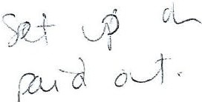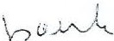

# Pa to  - Baile Audio S stems Ltd Va Prolive  - Blitz Fireworks Limited  - Cheshire Demolition  - Vikin  - Microshade  - Cheshire East Council  - Painters Su I ltd  - Laura Anne Hos italit  - Silk Brass  - D&G Bus ltd |  | Invoice No.  102092  Sl-1465 PFINV-272 4410123755  251100393907  11700333106  85527  INV-0567  405  10497 |  | Amount VAT Total Detail  £259.24 £51.85 £311.09 Armistice Da audio  £1,850.00 £370.00 £2.220.00 Remembrance Sunda audio  £225.00 £45.00 £270.00 Knowsle Road ski  £104.46 £20.89  £66.40 £13.28 hostin monthl cost  £166.00 £0.00 £166.00 Old  £18.33 £3.67 £22.00 Hammerite aint for Xmas tree railin s  £210.00 £0.00 £210.00 Further consultation re avilion  £350.00 £0.00 £350.00 Rembrance Da band  £2,116.80 £0.00 £2,116.80 Free buses on 21 and 28 June
11 Tufferman ltd |  | INV267797 |  | £665.93 £133.19 |  |  | £799.12 Shelvin |  | and stora e boxes for new office
12 |  |  |  |  |  | £0.00 | £0.00
13 |  |  |  |  |  | £0.00 | £0.00
14 |  |  |  |  |  | £0.00 | £0.00
15 |  |  |  |  |  | £0.00 | £0.00
161 | . l, |  |  | 4 |  | 1 £0.-00=='£-0.0l0- |  | ==~ |  |  | l
171 | . 1, |  | 4 |  | 1 £=0.0=0 |  | '-1£0-.00 "'="-l |  |  |  | l
After viewin the invoices. I have examined, verified and certified the above a ments and bank details and confirm that


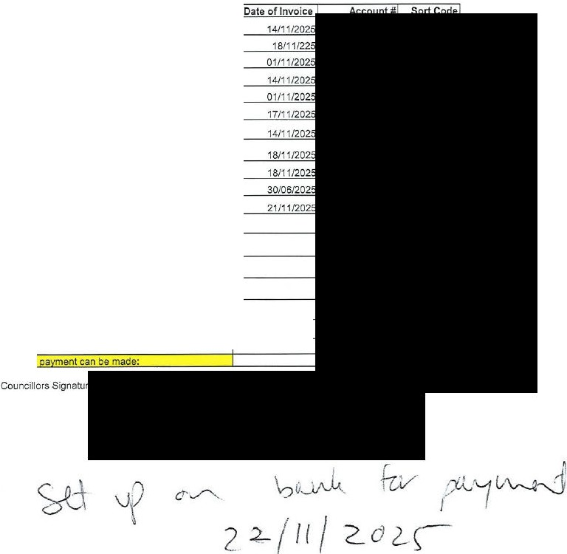
Councillor Signature

Office Signature:


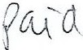

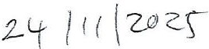

# | Pa to |  | Invoice No. | Amount | VAT | Total Detail
 | Manchester South Garden Services ltd |  | INV-2950 | £3 900.00 | £780.00 | £4 680.00 Allotment tree work
2 | Northwich Town Council |  | 8991 |  |  |  | aintln
3 | The Face Paintin Queen / D Grice |  | 2025-511 | £565.00 | £0.00 |  | aintln
4 | Christo her Hicke |  | DEC | £180.00 | £0.0D |  | aintln
5 | HOMEstead rown Rachel Morishire-Smith |  | 752 | £250.00 | £0.0D |  | aintln
6 | Chan in Lives To ether |  | GRANT | £1 DD0.00 | £0.00 | £1 D00.00 Grant
7 | Mace and Prestburv Philatelic Socie |  | GRANT | £250.00 | £0.00 | £250.00 Grant
8 | l&J Print ltd |  | 14647 | £250.00 | £50.00 | £300.00 Elmer banners
9 | l&J Print ltd |  | 14648 | £150.00 | £30.00 | £180.00 Christmas banners
1o | l&J Print ltd |  | 14654 | £72.00 | £14.40 | £86.40 Elmer window stickers
11 | L&J Print ltd |  | 14672 | £12.00 | £0.0D | £12.00 Ma or's char' osters
12 | L&J Print ltd |  | 14698 | £412.00 | £82.4D | £494.40 Elmer ma brochures
13 | l&J Print ltd |  | 14715 | £36.00 | £7.20 | £43.20 Xmascorrex anels
14 | Dead Good |  | 100 | £369.00 | £0.00 | £369.00 01625 Galle exhibit
15 | Shenton Garden Su lies ltd |  | 6427 | £77.94 | £15.58 | £93.52 MOT and osts. allotments
16  17 | Silk fm ltd Silk fm Ltd |  | 350496  350495 | £636.00  £656.60 | £127.20  £131.32  d bank deta | £763.20 Advertisin November 2025  £787.92 30 November Ste lntoXmas romo  ils and confirm that a ment can be made:
 | After viewin the invoices a ments an |  |  |  | £127.20  £131.32  d bank deta

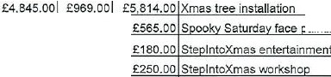
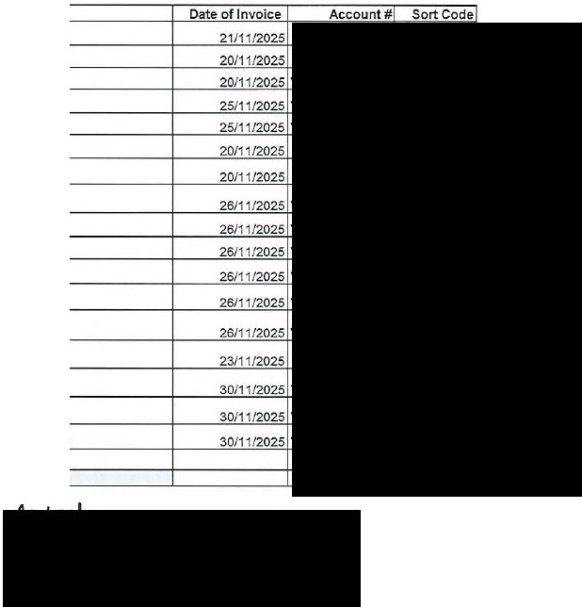
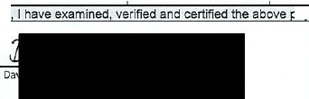
Councillor Signature 1:
Councillors Signature 2:

Office Signature:


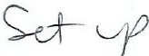
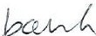
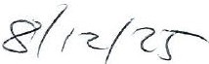
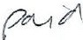

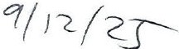

BATCH 1 DECEMBER 2025 Finance Committee 09 02 26 Agenda Item 7.2.4

Amount VAT Total Detail
Ste lntoChristmas
Choose Mace
1
Invoice No.
Pa to
#
£500.00 £0.00 £500.00 Music event Ste
291125
Chris Marie
2
£325.00 £0.00 £325.00 Ju lin entertainment Ste lntoXmas
INV-0294
Silk Museum
3
£180.00 £0.00 £180.00 Tots session Ste lntoXmas
614
Same Difference
4
£701.00 £140.20 £841.20 Victorian carol sin ers Ste lntoXmas
2025-182
D Grice Face Paintin Queen
5
£825.00 £0.00 £825.00 Face Paintin Ste lntoXmas
012
Guz o / Emma Welland
Ex enses
Abi Sherratt
29149
JRB Enter rise ltd
1066649
Shred Station
250120
St Michael & All An els' Church
NOVEMBER
SOLDO card
6
£997.87 £157.14 £1 155.01 Various - see breakdown
7
£136.00 £0.00 £136.00 Ste lntoXmas room hire
8
£40.00 £8.00 £48.00 Shreddin
9
£273.00 £54.60 £327.60 D waste ba s
1O
£9.07 £1.16 £10.23 Dehumidifers and
11
£1.000.00 £0.00 £1 000.00 Social media Elmer
350496
Silk FM
12
£636.00 £127.20 £763.20 Elmer advertisin

14759

L&J Print Ltd

13
£336.00 £67.20 £403.20 Elmer ma s
033
White Blossom
11700338241
Cheshire East Council
14
£61.83 £12.37 £74.20 Remembrance Sunda arkin
15
£175.00 £0.00 £175.00 Ste lntoXmas floral wreath
Viva La Ti i 71
16
1
£1,350.00 £0.00 £1 350.00 Giantti i Ii hts tables and benches
Twili ht
Date of Invoice

01/12/2025
28/11/2025
01/12/2025
01/12/2025
30/11/2025
30/11/2025
28/11/2025
24/11/2025
28/11/2025
30/11/2025
30/11/2025
03/12/2025
03/12/2025

+ '£=0.0"0 ='+£0. 00
+
1

==+ +

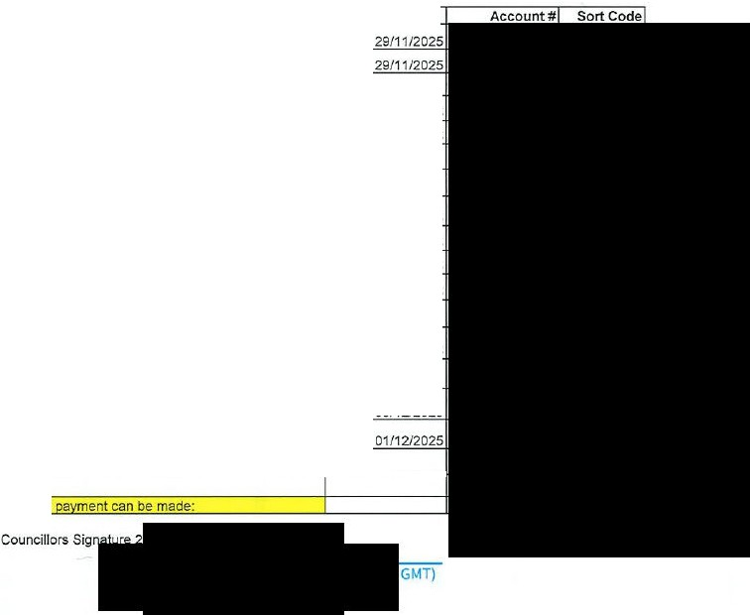
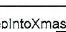
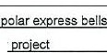



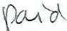
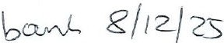
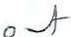
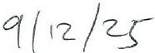
After viewin the invoices. I have examined. verified and certified the above a ments and bank details and confirm that Councillor Signature 1:

Office Signature:

