
Amount VAT
£54.70 £0.00
£150.00 £0.00
£54.70 £0.00
£1 203.20 £0.00
£1 554.70 £0.00
£23 666.15 £0.00
Total Detail
£54.70 Finance Committee BSO cost
£150.00 Full Council room hire
£54.70 Plannin Committee BSO cost
£1.203.20 Herita e O en Da room hire
£1.554.70 1261 Town Hall room hire
£23,666.15 December a ron
£2,640.00 Elmer advertisin
Date of Invoice
30/09/2025
30/09/2025
30/09/2025
30/09/2025
30/09/2025
01/12/2025
£2 200.00 £440.00
30/11/2025
£45.74
£172.50
£9.15
£0.00
£1 527.20 £305.44
£825.00 £165.00
£310.00
£54.89 Padlock. ke s bolts la e - allolments
£172.50 01625 Galle - 4th and final installation
£1 832.64 Stra Santas Twili ht Market
£990.00 Carousel hire Twili ht Markel
£0.00 £310.00 Ma ors wreath makin event
30/11/2025
01/12/2025
02/12/2025
05/12/2025
06/12/2025
£0.00
£0.00
£0.00
£0.00
£0.00
£0.00
l
l
l-�==+£-0.0-0
l-�==+£0-.0-0
'"£0".0'0-'""'-1
'£"0".00'-'""'-1
+
+
+
+
After viewin the invoices I have examined, verified and certified the above a ments and bank details and confirm that a ment can be made:
Councillor Signature 1
Councillors Signature 2:
Office Signature:
l
l
6�
7�

1
1
15
14

13
764
Rachel Mortishire Smith Homestead Grown
12
891
Nationwise Amusements Lid
11
INV-19934
Fools Paradise
1o
260
Luc Fitz atrick
9

55900
Richard Delane 2005 Ltd
8
SIA756994
Reach Publishin Services Ltd
7
DECEMBER
PQR Lid ta Shires
6
11700326034
Cheshire East Council
5
11700326035
Cheshire East Council
4
11700326036
Cheshire East Council
3
11700326037
Cheshire East Council
2
11700326038
Cheshire East Council
1
Invoice No.
Pa to
#


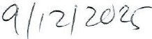
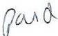
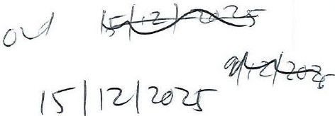

Amount VAT
11700338473
Cheshire East Council
11700338468
Cheshire East Council
11700338467
Cheshire East Council
11700338466
Cheshire East Council
Allotment
Vivien Evans and Michael Grist
1
Invoice No.
Pa to
#
£6.74 £0.00
2
£450.00 £0.00
3
£150.00 £0.00
4
£1,034.00 £0.00 £1,034.
5
£30,000.00 £0.00
399
Jess Kem
6
£120.00 £0.00
FirstDec25
Tina Russell-Cruise
7
£250.00 £0.00
100
INV-2939
-INV10932673
WaterPlus
ort Hive CIC
Bee
671508

LITE

8
£540.00 £108.00
9
£36.51 £0.00
£27,500.00 £5 500.00
11
£83.15 £0.00
12
£0.00 £0.00
£0.00
£0.00
14
£0.00
£0.00

13

lot. reduced amount allotment

contribution

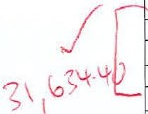
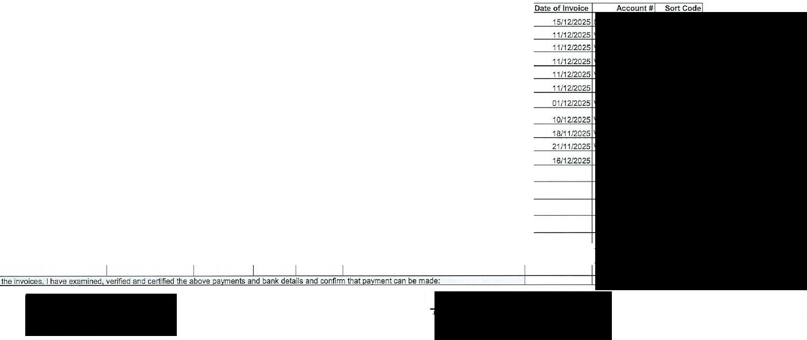

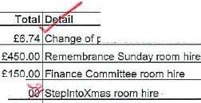
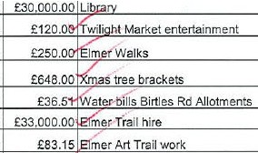

61--------------+---------+-----l-----'£""0"'.0::,0'+-----"'£0:c,-O�O'+----------------+ l-
1
17
£0.00
£0.00
15
1-- --11----------11-------1---'£""0"".0::.,0:.i-_-.:£a.::0.:::.0.:c0-1-- --4 1-

Afterviewin

Councillor Signature Councillors Signature 2:

Office Signature:


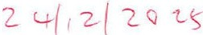
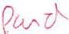
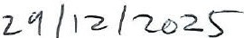


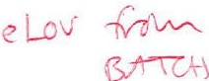
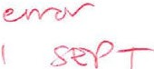

Invoice No. Amount VAT
Chelford Farm Su lies Ltd
Cheshire East Ccuncil
St John Ambulance
Cheshire East Ccuncil
Whirle Prima School
TransitDirect

1

1S.12.25
£820.00 £0.00

2 69 £250.00 £0.00

3
4
5
6
11700338856

SP25008581 11700343521
1230973
£166.00 £0.00 ,£1
£171.60 £34.32 £2 'Ii hi Market
£37,311.75 £7.462.35 -£44,77 service
£86.45 £17.29 "£"re' cin

JAN £35,828.43 £0.00 £3582 NW9971 £6,099.45 £1 219.89
INV-0328 £390.43 £78.09
350716 £560.00 £112.00

Services Ltd PROFORMA 226460250
14
15
£160.00
£32.00
£0.00 £0.00
£0.00
£0.00

1s1-------------+---------+------+- o-'-,ot--_�£=0=.o-'-,ot------------------+ +-

�£=0.=

11, ,
�£-o.=..o..o...
£�0�.o=o+-

After viewin Councillor Signature 1:

Office Signature:
ents and bank details and confirm that

Councillors Signature 2:

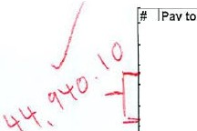
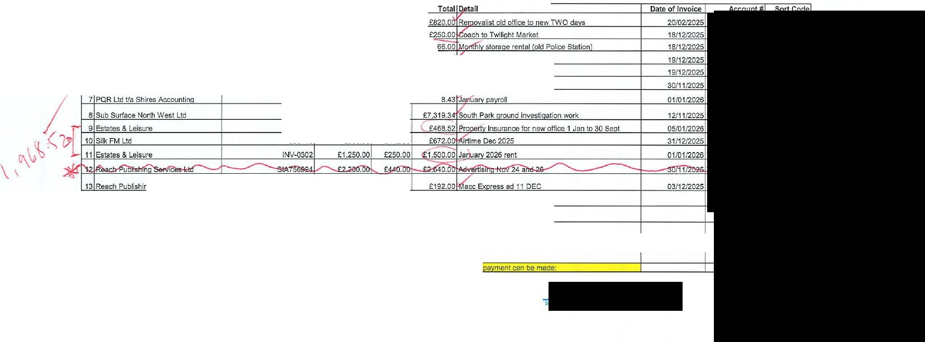
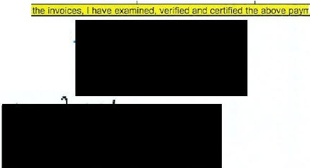

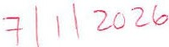


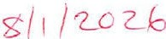

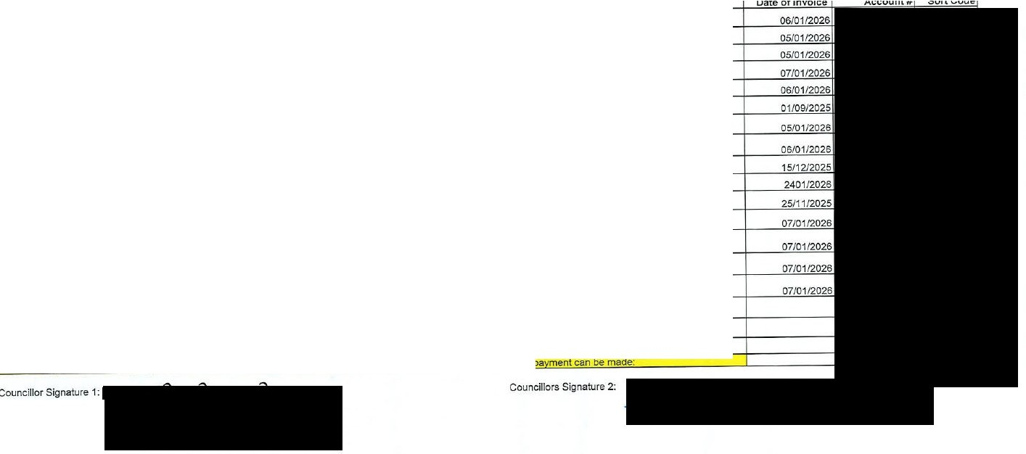
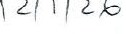
After viewin the invoices. I have examined verified and certified the above a ents and bank details and confirm that
Office Signature:
# | Pa to | Invoice No. |  | Amount | VAT | Total Detail
 | 1 Macclesfield in Ma |  | 06-Jan-26 | £2 080.00 | £0.00 | £2,080.00 Macci | 2nd and final SLA a ent
 | 2 Canda Co Ltd |  | 100263717 | £127.10 | £25.42 | 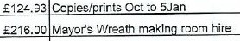  £152.52 Rental | ier Ja�arch ind
 | 3 Canda Co Ltd |  | 100264165 | £104.11 | £20.82
4 Macclesfield United Reformed Church Chari |  | 428 |  | £180.00 | £36.00
5 LITE |  | 770071 |  | £8 297.25 | £1.659.45 | earSLA
6 LITE |  | 670832 |  | £450.00 | £90.00
7 Emma Welland I Guz o Creative |  | 013 |  | £1.000.00 | £0.00 | £1.000.00 Elmer social media services
8 Niche Event Hire |  | 6387 |  | £280.00 | £52.00 | £312.00 Lantern Festival edestrian barrier hire
9 Al ha Orne a Secumies |  | 105798 |  | £387.36 | £77.47 | £464.83 Twili ht Market secu • services
1o Foors Paradise |  | INV-19989 |  | £2 467.00 | £493.40 | £2,960.40 Lantern Festival entertainment
11 Prism Solutions |  | 231139 |  | £9 933.00 | £1,986.80 | £11 919.60 Installation of hardware network etc in new office
12 Painters Su I Limited |  | 86321 |  | £6.48 | £1.30 | £7.78 Paint
13 Shires Accountan1s |  | SHl-3150 |  | £105.00 | £21.00 | £126.00 Calculation of back a ad·ustments
14 Niche Event Hire |  | 6389 |  | £290.00 | £58.00 | £348.00 17Feb Pancake Race barrier hire
15 Niche Event Hire |  | 6388 |  | £240.00 | £48.00 | £288.00 4March2025 Pancake Race barrier hire
16 |  |  |  |  | £0.00 | £0.00
17 |  |  |  |  | £0.00 | £0.00


1 f c� �
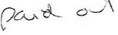
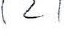
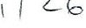

Finance Committee 09 02 26 Agenda Item 7.2.4

BATCH 2 JANUARY 2026

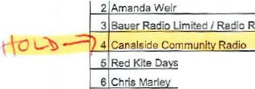
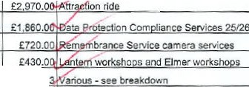
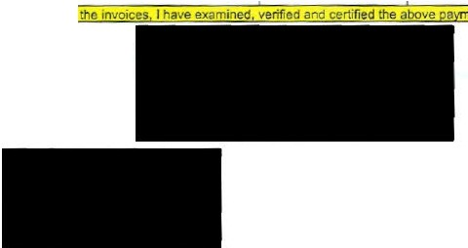
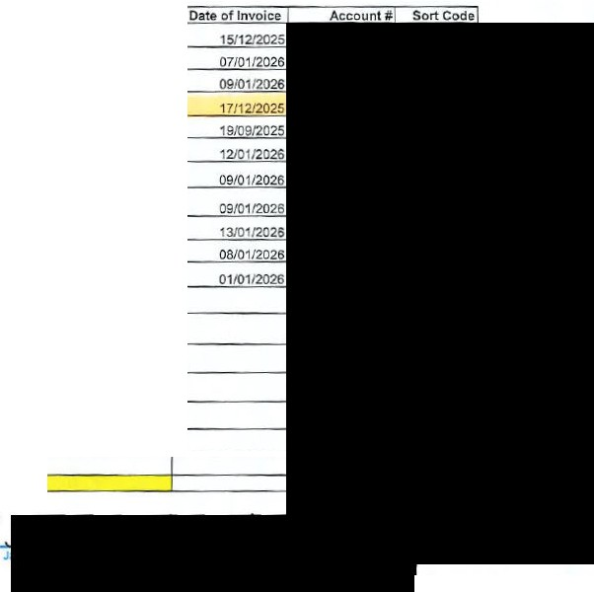
# Pa to
1 Nicola Mellor

/CLWinlow
Invoice No.

ts
EXPENSE
EXPENSE
Order 2195
1610105156
Amount VAT
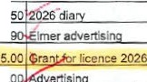
£4.60 E0.00 £4. rkin costs 15 and16 Dec
£1.25 £0.25 £1.
£4,622.42 £924.48 £5,546.
!:1095.00 £0.00
INV.05898
5390
898
120126
INV1909251
£50.00 £0.00 £50.
£350.00 £0.00 £350. t Lantern Pamde

- Nationwide Amusements Ltd
- JOH Business Services Ltd
- Event E ul ment Hite
- Macclesfield Communit Art$ ace

SOLDO
12
13
14
15
£2475.00 £495.00
£1.550.00 £310.00
£600.00 £120.00
812601
£430.00 £0.00
DEC
£861.81 £151.32 £1 013.1
£0.00 £0.00
£0.00 £0.00
£0.00 £0.00
£0.00 £0.00

161
171
+ '=£=0.+00
+-'==£=0.+00
"£=0.0:0=+ +
"£=0.0:0=+ +

After v1ewin Councillor Signature 1:

Office Signature:
ents and bank details and confirm that a ment can be made:

Councillors Signature 2:

:G�\V AAJ')�

+ 2-v{ I /2._£

<:;rd vr/1 r'-7 ( ( ( 2-<6
tv
PU-\�-V' oJ '<- 2-/ ( 26

