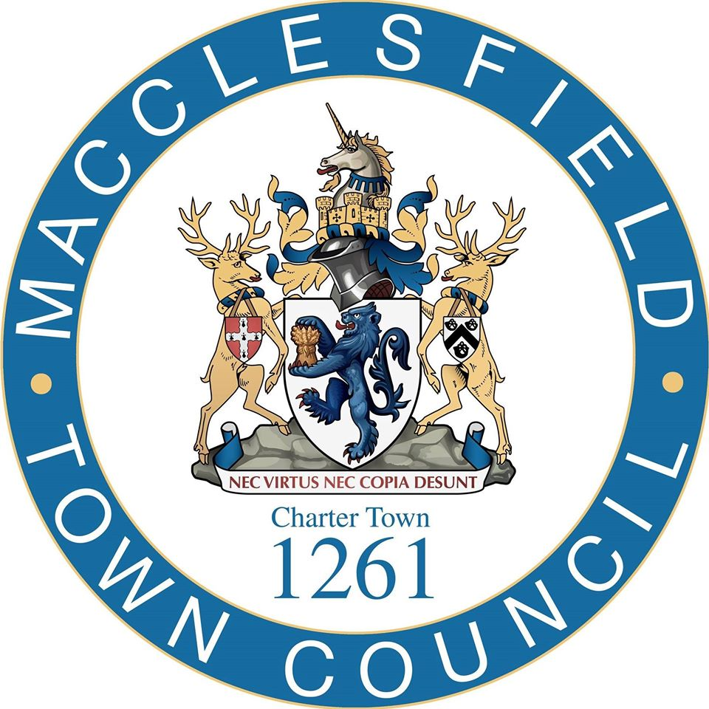

Provision of Florals Iin
Macclesfield Town Centre

Questionnaire Response Template

Instructions for Bidders

- Bidders must respond to the questions set by entering their responses directly into this form. Attachments maybe added where deemed necessary.
- Marks are awarded for clear and concise responses which are relevant to the requirement, tailored to this procurement, with examples and explanations given when applicable. Where possible responses should be structured and concise, and where appropriate clearly set out the bidder’s offer
- All information requested should be provided in the order and format set out in this tender. Unsolicited attachments, documentation and / or cross referencing of responses will not be evaluated unless they are expressly requested.
- Where a specific question in the template asks for additional information, this should be uploaded with the tender submission. Such material should be clearly marked and subtitled with your organisation’s name and the question to which it relates. General sales literature or promotional brochures etc. will not be considered.
- The word limits referred to are the maximum number of words applicable to each response. Word limits exclude titles, headings, charts, tables, and diagrams although these should not be excessively used to increase word count. Responses that exceed the word limit will only be considered up to the word limit.
- Please note that we may request clarification of the responses provided or ask for additional information to conclude assessment.
- All questions will be scored on a scale of 0 – 5 and will be weighted in line with the instructions provided within the ITT.
- Bidders should ensure they have read and understood the entire tender pack, before completing this document. Your response should be tailored to the requirement, with any firm offers, or initiatives likely to be appended to / adopted in any final contract.

Name of bidding organisation:

Section 1 Relevant Experience

Q1 – Relevant Experience (minimum 2)

Contracts should have been delivered during the past three years and you may not reference MTC in this question. Please note that we may take up references from the contacts listed to verify the content of this response, and you should be prepared to forward any necessary details to assist with this.

(i) Customer organisation
Scope of contract

Start & completion dates

Approx. contract value (£)

Brief description of contract (max 200 words) including evidence of delivery in line with MTC’s requirements
(ii) Customer organisation
Scope of contract

Start & completion dates

Approx. contract value (£)

Brief description of contract (max 200 words) including evidence of delivery in line with MTC s requirements
(iii) Customer organisation
Scope of contract

Start & completion dates

Approx. contract value (£)

Brief description of contract (max 200 words) including evidence of delivery in line with MTC's requirements

Q2 Key Staff

Please give an overview of the key staff within your organisation, and the key staff that would be deployed to manage this contract if you are successful, including provision of appropriately skilled and qualified staff. You may include abridged CVs as separate attachments to support your response but it is not necessary.

Bidder Response – Max 500 words (not including any attachments)

Section 2 Cost and Design

Q1 Please provide clear cost options below/attached and attach high quality images of each option If appropriate

Bidder Response – Max 500 words (not including any attachments)

Q2 Please provide overall final costs for each component
Bidder Response – Max 500 words (not including any attachments)

Section 3 Support Service

Q1. Tell us about the support service to respond to maintenance and repairs and how long it will take you to physically respond to any issues.
Please confirm that this can be adhered to and provide any additional information relating to this below.

Bidder Response – Max 500 words (not including attachments)

Section 4 Environmental Sustainability

Q1 Please set out how you will ensure environmental sustainability in the delivery of this project. Your response should give details on your own practices, and how you will incorporate environmental sustainability Into work practices.

Bidder Response – Max 500 words

Section 5 Social Value

Q1 Please give an overview of the social value commitments you will make to MTC if appointed to deliver this contract.

Bidder Response – Max 500 words

