Report Purpose:
10. Comms and Website Update

Author:
Communications Officer (Town Centre Manager)

Comms and Website Update
The Comms Officer continues to post on average of twice a day across the Town Council’s social media platforms
Social Media stats for the last full month (January 2026) are below

Facebook followers
From 7839 to 8165 which is a 4.1% increase

Insta followers
2790 followers to 2901 which is a 3.9% increase

Some commonly used social media terminology
How well our social media is doing can be judged on a number of factors – reach, likes, impressions and engagement.
What is reach? Reach is the total number of unique users/people who see our content in their social media feeds.
What are likes? They demonstrate that people are interested in what we have to say and value our content
What are impressions? Impressions are the number of times a person sees our content on their social media feed. They may see if because they follow our pages, or they may see if it because people they know have shared it.
What are engagements? This is a measure of how people interact with our content. Do they share it, comment on it, like it, watch the video, save the post? High engagement levels show an interested audience.

Social Media stats for facebook

Views in last 28 days – 294k this is a decrease, but to be expected as we are no longer sharing Elmer content
Visits to Facebook page – 6.3k
Interactions 2.3k

Top content by reach in the last 28 days, TBU meeting at the Bollington Brewery Tap to talk about the UK Town of Culture bid, 30% increase in footfall for the Macclesfield Lantern festival, a reel from the Lantern Festival, save the date for 1261 and FA cup third round day.

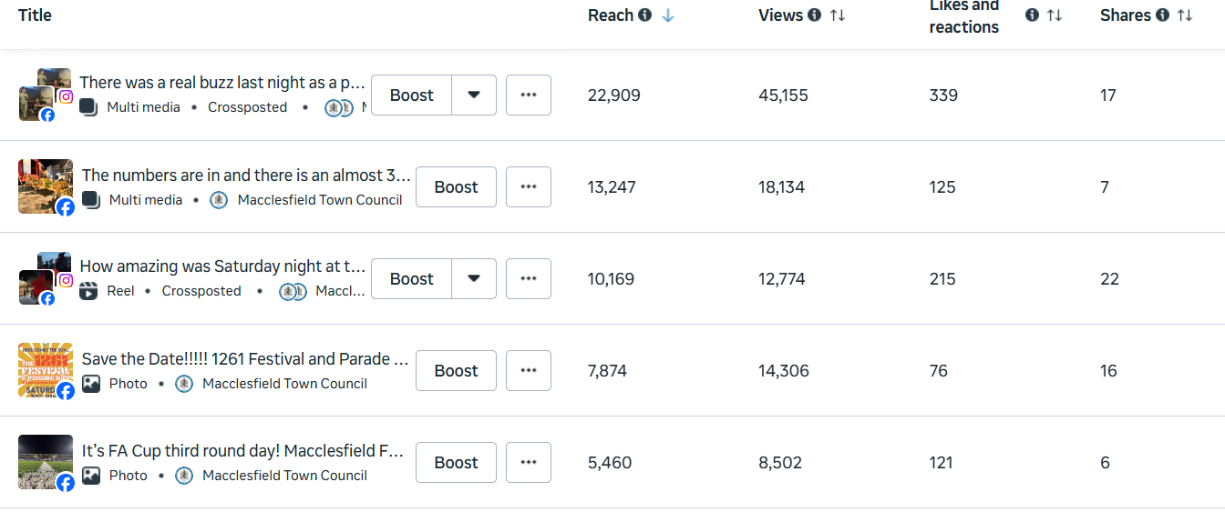

The Mayor of Macclesfield facebook continues to be popular with posts promoting the Mayor’s events and attendances, and currently has 895 followers at the time of writing.

Mailing list
Subscription increased to 160. Everyone will receive updates when news or event items are updated on the websitem, as well as when specific mailers are sent out. We have sent out a specifice newsletter with a full list of this years free events, and a newsletter will be going out with the precept information before the end of February.

Other Marketing
As discussed the Comms Officer is pushing to increase our reach by ensuring that more printed material and other marketing methods are utilised.
Spotlight on ……
The Town Council has an agreement to sponsor Canalside Radio. The amount of sponsorship is £1175 which covers Ofcom FM Licenses x 2 / Canstream Digital Licence / Digital Streams

In return the Town Council receives regular Thank You’s and mentions on the website, apps and socials, and our events are shared on the radio, on socials and the Thread.

Listenership figures for Canalside hover around the 12,000 mark with around 2,300 listening ‘at-any-one-time’. The bulk of their listenership is around Macclesfield and Bollington. However later this year they will be moving to SS (small scale) DAB which will cover East Cheshire and South Manchester.

Canalside operate solely not-for-profit and all monies received are invested back into the community project. They are also proud to offer volunteering and training opportunities to all ages.

Winter
- Comms sent to Macc Express and Nub News re Christmas events and Elmer
- Comms sent to local businesses re events and Elmer
- Local Radio advertising for Christmas and Elmer
- North West radio advertising for Elmer, with mentions of shopping and Christmas events
- Article in the MEN on Elmer print and website
- Call to Arms video released to great response
- Front page and ad inside Local People which goes to approx. 18k homes
- Email and poster sent to all schools re Elmer
- Radio interview re Lantern Festival and Lunar New Year
- Comms sent to Macc Express, Nub News, The Post, I Love Macclesfield, plus various large scale employers such as AZ and Macclesfield Hospital.
- Mailing list email sent re all dates for events this year.
- Paid advertisements with Red Kite Days on socials who have 14k followers, which saw over a 100 like and attracted 51 comments and 31 shares
- 